**Exploratory Analysis of RainFall Data in India for Agriculture.**

**Team ID: PNT2022TMID51361**

# WAY TO INSTALL ANACONDA

**STEP 1: Download and Anaconda.**



**STEP 2: Install the Anaconda.**

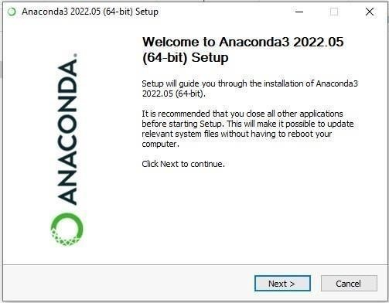

**STEP 3: Click I Agree.**

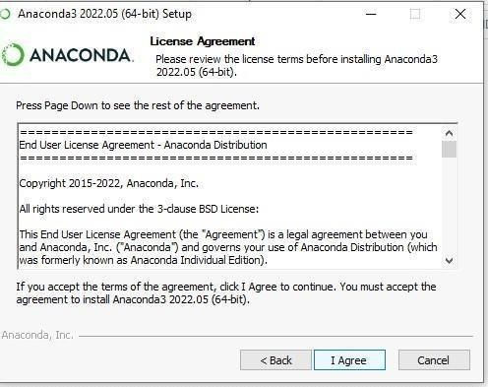

**STEP 4: Choose the Installation Location.**

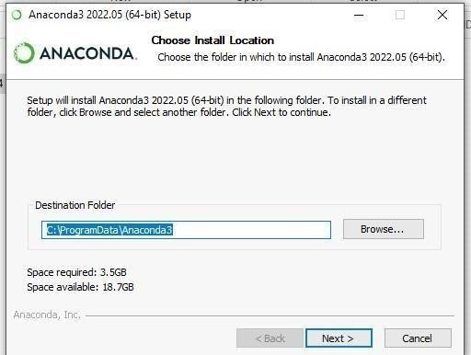

**STEP 5: Installing the Requiring packages.**

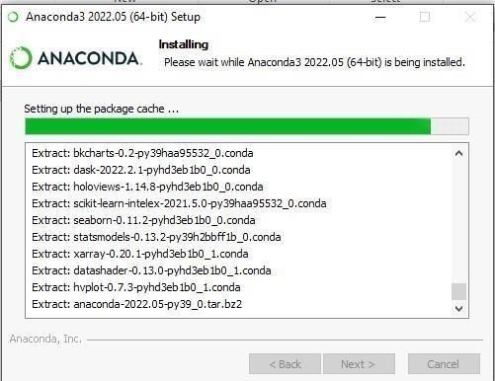

**STEP 6: Setting up the base environment.**

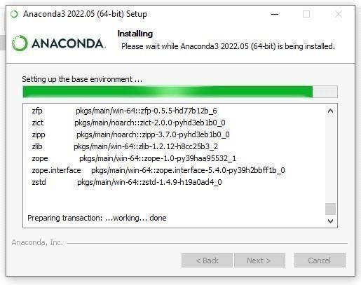

**STEP 7: Successfully Installed and check the Anaconda Navigator is working or not.**

